Scott Ruen

108 S. Humphrey Cir
Shawano, WI 54166

03/25/2026

Home Run Inspection Service, LLC
626 E Center St
Shawano, WI 54166
Phone: 715-853-9718
Report Index

Cover Page 1
Report Index 2
Inspection Summary 3
General 10
Exterior 11
Roofs 15
Chimneys 16
Garage Exterior 17
Garage 18
Kitchen 20
Bathrooms 21
Interior 23
Attic 24
Electrical 26
Structure 27
Basement/Foundation 27
Plumbing 30
Laundry 32
Water Heater 33
Heating and Cooling 34
Furnace 34
Air Conditioning 35
Space Heater 37
Heating 37

Inspection Summary

Inspection Summary

Definitions
Note: All definitions listed below refer to the property or items listed as inspected on this report at the time of the inspection

Functional - Performing its function and its condition is appropriate for its age and/or use
Defect - A condition of any component of an improvement that a home inspector determines, on the basis of the home inspector's judgment on the day of an inspection, would significantly impair the health or safety of occupants of a property or that, if not repaired, removed, or replaced, would significantly shorten or adversely affect the expected normal life of the component of the improvement.
Further Evaluation - Item is not functioning as intended or appears not to be functioning as intended. Needs further evaluation by a qualified professional in the related field of work.
Needs Repair - The condition of the item warrants repair but does not pose a health or safety concern nor rise to the level of Defect.
Maintenance - Maintenance of item is recommended to prevent premature failure or to maintain its functionality.
Monitor - Currently functioning but condition and/or age indicates that limited remaining life is expected. Client is advised to budget for replacement or upgrade.
Not Inspected - Item was unable to be inspected for safety reasons, lack of power, inaccessible, not visible, disconnected at time of inspection or was not within the scope of this inspection
Not Present - Item not present or not found at time of inspection.
Note
This Summary page (or group of pages) is provided for convenience and is not a substitute for reading the entire report and should not be relied upon as the complete list for the client's reference, A home inspector may not report on the market value or marketability of a property or whether a property should or should not be purchased.
Noted Defects
Items that have a notable defect according to the definition noted
Exterior
Driveway/Slab
Concrete
Cracks: Major cracks from heaving/settling.

Potential Safety Hazards
Note: Items considered to be possible safety hazards. Items listed here also fall under the definition of a defect. Exterior
Walks/Patio
Brick/Pavers/Stone
Trip hazard.
Electrical
Outlets
Suggest Ground Fault Circuit Interrupter. See Note on Electrical Section, Required since 1973. GFCI IMAGE.
Garage
Interior Walls/Ceiling
Fire separation missing at wall/ceiling in garage. This is a potential fire hazard.
Doors
House Door
Not fire resistant. Suggest a "20 minute door" rated for use between an attached garage and a house.
Garage Door Opener
Garage door opener did not mechanically reverse to pressure. This is a potential hazard. Adjust reverse sensitivity.
Garage Electrical
Suggest Ground Fault Circuit Interrupter protection at all garage outlets. See note on Electrical section, Required since 1978.
Garage Attic Fire Blocking
Missing fire blocking. This is a potential safety hazard. Suggest consult a carpenter and/or the local code authority.
Kitchen
Kitchen
Sink
No air gap device for dishwasher drain line. This can cause dirty water to flow back into the dishwasher.

Electrical
Suggest Ground Fault Circuit Interrupter protection at all kitchen outlets. See note on Electrical section, Required since 1987.
Interior
General Areas
Smoke Detectors
Suggest installing a CO detector on each level.

Electrical
Main Panel
Condition
Double tapping of neutral wires.

Basement/Foundation
Unfinished Basement Areas
Electrical
Suggest Ground Fault Circuit Interrupter. See note on Electrical section, Required since 1990.
Plumbing
Gas Piping
Condition
Recommend bonding gas to water line (this can be done by the water heater)

Water Heater
Water Heater
Condition
The water heater relief valve overflow pipe needs to be extended to within 6 inches of floor. This is potential hazard and needs repair.

Deferred Cost Items
Items that may need repair or replacement in the next 5 years:
Air Conditioning
Air Conditioner
Age
Approximately 26 years old.
Heating
Age
Gas Space Heater
>20 years.

Important Maintenance Items
Note: Items listed are identified as needing repair, further evaluation, maintenance, or monitoring. Exterior
Siding
Hardboard
Damage noted at bottom row, southwest corner. Maintenance is very important to preserve hardboard siding. It is critical to maintain paint and caulk.
Chimneys
Chimney
Chimney Recommendations
Have flues cleaned and evaluated annually.
Garage Exterior
Siding
Condition
Deteriorated edges. Recommend scrape and paint.
Garage
Doors
Passage Door
Southwest door needs paint and binds at bottom.
Interior
General Areas
Fireplaces
Damper not opening all the way.
Attic
Insulation
Condition
Suggest adding insulation.
Ventilation
Condition
Suggest adding air baffles before adding insulation.
Electrical
Service Information
System Grounded To
No water meter jumper present at the time of inspection.

Plumbing
Utility Sink
Sink
Cold water handle seized up.

General

General Information

Property Inspected
108 S. Humphrey Cir
Shawano, WI 54166
Date Of Inspection
03/25/2026
Client
Scott Ruen

Real Estate Agent
Listing Broker
Jim Leisner

Inspector
Home Run Inspection Service, LLC
715-853-9718
Attendees
Client.

Hazardous Materials

Determining the presence or absence of hazardous materials such as lead or asbestos is beyond the scope of this inspection.

Building and Site Information

Building Faces
North. Though the building may or may not face directly North, references to direction in this inspection report assume that the front entrance of the building faces North.
Building Type
Single family.
Building Occupancy
Occupied, seller was at home.
Weather Conditions
Temperature: 32° F to 65° F.

Please make special note that this report is provided as a home inspection with specific limitations as defined in the Inspection Agreement. This is not an engineering report.

Exterior

Siding

Hardboard
Damage noted at bottom row, southwest corner. Maintenance is very important to preserve hardboard siding. It is critical to maintain paint and caulk.

Windows/Doors

Condition
Appear undamaged.

Overhangs/Trim

Condition
Appear functional, Appear undamaged.

Walks/Patio

Brick/Pavers/Stone
Trip hazard.

Driveway/Slab

Concrete
Cracks: Major cracks from heaving/settling.

Grading

Grading
Low or flat areas: Various locations.

Concrete Porch/Stoop

Limitations
Carpeting restricts inspection.

Location
Front.
Condition
Appears functional, Appears undamaged.

Concrete Porch/Stoop

Location
Rear.

Condition
Appears functional, Appears undamaged.

Exterior Faucet(s)

Exterior Faucet(s)
No flow at one or more faucets. The water supply to the faucet(s) may be turned off inside. Testing shut off valves is beyond the scope of this inspection.

Electrical

Outlets
Suggest Ground Fault Circuit Interrupter. See Note on Electrical Section, Required since 1973. GFCI IMAGE. | 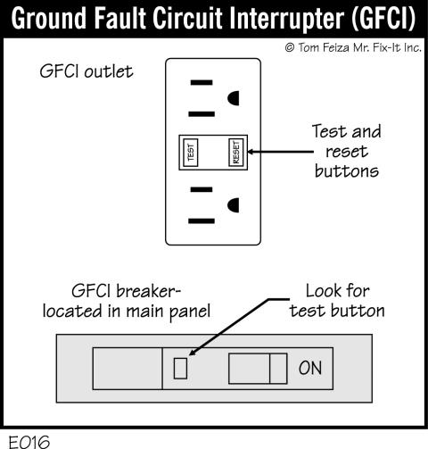

Exterior Lighting Fixtures
Outside light did not turn on. Photo eye may be off. Appear undamaged.
Power Feed
Overhead, Appears functional, Appears undamaged.

Sump Discharge

Appears undamaged, Sump pump discharge extends underground. Monitor for freezing.

Downspouts

Metal, Discharges above grade, Appears undamaged.

Gutters: View From Ground

Appear undamaged.

Roofs

Inspection Limitations

Inspection Limitations
Height.
Roof Inspected By
Binoculars, From the ground. Metal roofs are not walked on.

Pitched Roof

Material
Metal.
Layers
Unknown, One layer observed.
Condition
Appears functional, Appears undamaged.
Recommendations
Monitor exposed fasteners.

Flashings

Plumbing Stack
Appears undamaged.

Gutters: View From Roof

Roof not accessed.

Pitched Garage Roof

Garage Roof
Same material as and similar condition to house.

Garage Gutters: View From Roof

Appear undamaged. Viewed from upper level windows.

Chimneys

Chimney

Location
Two flues located in one chimney structure.
Chimney Inspected By
Binoculars, From ground.
Type of Chimney
Masonry.
Chimney Cap
Top of concrete cap not visible.
Flue Type
Tile.
Flue Condition
Interior not inspected.
Chimney Structure
Appears functional, Appears undamaged.
Rain Cover
Appears undamaged.
Chimney Recommendations
Have flues cleaned and evaluated annually.
Chimney Structure
Appears undamaged.

View Up Chimney
Restricted view.

Flashings

Chimney
Metal, Appears functional, Appears undamaged.

Garage Exterior

Siding

Type
Hardboard.
Condition
Deteriorated edges. Recommend scrape and paint.

Exterior View of Windows/Doors

Condition
Older/worn, Appear undamaged.

Overhangs/Trim

Condition
Appear functional, Appear undamaged.

Grading At Garage

Grading
Part or all of ground around the building was not visible at the time of inspection due to snow cover.

Exterior Electrical

Outlets
None observed.
Exterior Lighting Fixtures
Appear functional, Appear undamaged.

Garage Gutters: View From Ground

Appear functional, Appear undamaged.

Garage Downspouts

Roof Drainage
Appear functional, Appears undamaged.

Garage

Interior Limitations

Ceiling
100% finished.
Walls
100% finished.

Type

Attached.

Building Structure

Wood frame, Appear functional, Appears undamaged.

Interior Walls/Ceiling

Appear functional, Appear undamaged, Fire separation missing at wall/ceiling in garage. This is a potential fire hazard.

Windows

Stationary windows appear undamaged.

Doors

Passage Door
Southwest door needs paint and binds at bottom.
House Door
Not fire resistant. Suggest a "20 minute door" rated for use between an attached garage and a house.
Vehicle Door
Appears functional, Appears undamaged.

Floor Slab

Appears functional, Appears undamaged.

Garage Door Opener

Did reverse at safety beam, Garage door opener did not mechanically reverse to pressure. This is a potential hazard. Adjust reverse sensitivity.

Garage Electrical

Suggest Ground Fault Circuit Interrupter protection at all garage outlets. See note on Electrical section, Required since 1978.

Foundation

Concrete Block
Appears functional, Appears undamaged.

Foundation Wall Movement

Movement
No significant movement evident.

Garage Attic Limitations

Attic Access
Ceiling access hatch: Viewed from hatch.
Inspection Limitations
Stored items.

Garage Attic Insulation

R-value
Approximate "R" value for ceilings/floor: R-11.
Insulation Types
Fiberglass.
Condition
Uneven insulation levels.
Vapor Barrier
None visible.

Garage Attic Ventilation

Type
Soffit venting observed.
Condition
Appears to have sufficient ventilation at the time of inspection.

Garage Attic Fire Blocking

Missing fire blocking. This is a potential safety hazard. Suggest consult a carpenter and/or the local code authority.

Garage Attic Roof Structure

Type
Trusses, Plywood sheathing.
Condition
Appears functional, Structure appears undamaged.

Kitchen

Kitchen

Sink
Sink, faucet, and piping appear undamaged. No air gap device for dishwasher drain line. This can cause dirty water to flow back into the dishwasher. | 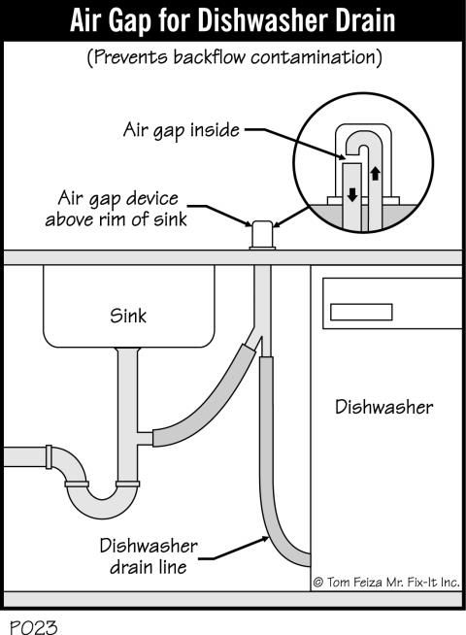

Non-professional drain material noted. Monitor for clogging.

Garbage Disposal
Appears to function properly.
Cabinets/Countertops
Appears functional, Appears undamaged.
Exhaust Fan
Built into microwave, Recirculating, Appears functional.
Heat/Cool Sources
Heat source provided.
Stove Utility
Electric.
Electrical
Suggest Ground Fault Circuit Interrupter protection at all kitchen outlets. See note on Electrical section, Required since 1987.

Bathrooms

Central Bathroom

Location
First floor.
Toilet
Appears functional, Appears undamaged.
Sink
Sink, faucet, and piping appear undamaged.
Counter/Cabinet
Appears functional, Appears undamaged.
Electrical
Appears functional (GFCI Protected)
Ventilation
Window: Appears functional, Appears undamaged, Fan: Appears functional.
Heat/Cool Sources
Heat source provided.

Upstairs Bathroom

Toilet
Appears functional, Appears undamaged.
Sink
Sink, faucet, and piping appear undamaged.

Counter/Cabinet
Appears functional, Appears undamaged.
Electrical
Appears functional (GFCI Protected)
Ventilation
Window: Appears functional, Appears undamaged, Fan: Appears functional.
Heat/Cool Sources
Heat source provided.
Tub
Tub, faucet/spout, and drain appear undamaged.
Shower Plumbing
Appears to function properly.
Shower Enclosure
Appears functional, Appears undamaged.

Interior

General Areas

Location
General areas.
Limitations
Furnishings prevent/limit full inspection.
Exterior Doors and Trim
Wood: Appears functional, Appears undamaged.
Interior Doors and Trim
Appears functional, Appears undamaged.
Windows and Trim
Limited access: shades/blinds/location/plastic film. Double hung, Appear functional, Appear undamaged.
Ceiling and Walls
Ceiling and wall framing is not observable due to finishes/insulation. Appears functional, Appears undamaged.
Floors
Appears functional, Appears undamaged.
Heat/Cool Sources
Appears functional, Appears undamaged.
Smoke Detectors
Alarm(s) sounded when test button was pressed. Suggest installing a CO detector on each level.

Ceiling Fans
Appears functional, Appears undamaged.
Stairs/Balconies
Appears functional, Appears undamaged.
Fireplaces
Masonry unit in dining area. Damper not opening all the way.
Masonry unit in basement. Appears functional, Appears undamaged.

Attic

Limitations

Attic Access
Ceiling access hatch: Viewed from hatch.

Insulation

R-value
Approximate "R" value for ceilings/floor: R-11 to R-19.
Insulation Type(s)
Not determined (possibly fiberglass)

Condition
Suggest adding insulation.
Vapor Barrier
None visible. Suggest painting ceilings below attic with a vapor retarding primer paint.

Suggest consulting with an Energy Rater or Home Performance Professional to solve any condensation, heat loss, and comfort problems.

Ventilation

Type
Soffit venting observed.
Condition
Suggest adding air baffles before adding insulation. | 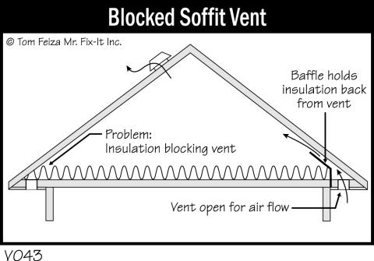

Attic ventilation must be adequate to prevent structural moisture damage, ice dams, mold, and premature roof failure. Ventilation needs change depending on occupancy.

Exhaust Ducts

Vent To
Upper bathroom fan vents through roof. Main level bathroom fan termination not found.
Condition
No adverse issues noted.

Roof Structure

Limitations
Roof structure not visible: 20% to 30%.
Type
Trusses, Plywood sheathing.
Condition
Structure appears functional, Structure appears undamaged.

Electrical

Service Information

Service Rating
Main service rating: 200 amps.
Main Box Rating
200 amps, 240 V, 120 V.
Main Breaker/Fuse
200 amps.
Main Service Wire
200 amps, Aluminum.
Wire Protection
Circuit breakers.
Branch Wires
Material: Copper, Types of branch wires: Non-metallic cable (Romex)
System Grounded To
It appears that the electrical system is grounded to a ground rod. Ground rods are buried in the ground and usually not visible at the time of inspection. Bonded at water pipe. No water meter jumper present at the time of inspection.

Capacities noted are determined by a visual inspection only. Capacity concerns should be directed to a licensed electrician.

Main Panel

Location
Basement.

Condition
Appears functional. Double tapping of neutral wires.

Low voltage wiring is beyond the scope of this inspection.

Finishes restrict inspection of branch circuits.

All electrical concerns are potential safety hazards and should be evaluated/repaired immediately by a licensed electrician.

Structure

Foundation Configuration

Basement: 100%.

Building Structure

Exterior Walls
Finishes restrict inspection. Wood frame.
Overhead Beams
Steel, Appears functional, Appears undamaged.
Overhead Joists
Wood lumber, Appears functional, Appears undamaged.
Subfloor
Plywood, Appears functional, Appears undamaged.

Basement/Foundation

Inspection is limited to visible areas only.

Inspection Limitations

Floor
Floor not visible due to carpet: 50% to 60%.
Walls
Painted foundation walls (old): 100%.
Ceiling
Finished ceiling: 50% to 60%.

Basement Stairs

Appears undamaged.

Foundation Structure

Type
Concrete block.
Condition
Appears functional, Appears undamaged.

Cracks
No cracks evident.
Cracks may indicate that there is movement in a wall and the wall has technically failed. The most significant cracks are horizontal or vertical wall cracks that go through the block and are combined with inward deformation, bowing, or movement. A basement with a cracked wall may continue to progressively get worse. Sometimes cracked walls remain unchanged indefinitely.

Foundation Wall Movement

Movement
No significant movement evident.

Foundation Settlement

No evident differential settlement present.

Foundation Seepage or Dampness

Degree
None evident at the time of inspection.

Since about 1920, basements have been designed with drain tile systems to remove water and water pressure. Drain tile systems are not visible for inspection; only the end of the tile is visible at the sump crock or the floor drain palmer valve. Stains and signs of moisture are often due to poor exterior drainage of surface water, but could be due to poor exterior drainage of surface water, but could also indicate a plugged or damaged drain tile system. It is possible the signs of moisture may have been caused by a condition that no longer exists. IT IS IMPOSSIBLE TO PREDICT THE SEVERITY OR FREQUENCY OF MOISTURE PENETRATION ON ONE INSPECTION VISIT.

Leakage or Signs of Leakage

Water Stains
None apparent at the time of inspection.

Basement Floor

Concrete: Appears functional, Appears undamaged.

Foundation Drainage

Drain Tiles
Present.
Sump Pump
Appears to function normally.

Footings and drain tiles are not visible for inspection.

Unfinished Basement Areas

Electrical
Suggest Ground Fault Circuit Interrupter. See note on Electrical section, Required since 1990.

Plumbing

Water Main

Source
Municipal.
Location
The main water shut off is located on the North basement wall.

Material
Copper.
Condition
Appears functional, Appears undamaged.

Main shut-off not tested. Suggest verifying that the main shut-off valve works properly before it is needed in an emergency.

Functional Water Flow

General Areas
Appears adequate.

Water Pipes

Material
Copper.
Condition
Appears functional, Appear undamaged.

Valves not operated.

Drain Pipes

Type of System
Municipal sewer.

Material
Steel, Cast iron, Plastic, PVC.
Condition
Appears functional, Appears undamaged.

Plumbing Vent Pipes

Material
Cast iron.
Condition
Appears functional, Appears undamaged.

Gas Piping

Location of Gas Shut Off
At exterior meter and at furnace/water heater.
Condition
Appears functional, Appears undamaged. Recommend bonding gas to water line (this can be done by the water heater)
Location of Gas Shut Off
The main gas shut off is located outside on the West side of the building.

Utility Sink

Location
Basement.

Sink
Cold water handle seized up.

Laundry

Laundry

Location
First floor closet.
Washing Machine Drains To
Washing machine discharges into a drain in the wall. Not tested. Inspection is limited to visible areas only. | 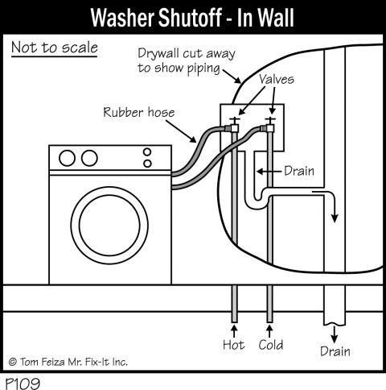

Dryer Utility
Electric.
Dryer Venting
Suggest replacing foil dryer vent tubing with a metal dryer vent. Foil vents tend to trap lint, which causes dryers to operate less efficiently. Vents to: Vents to outside wall.
Electrical
Not accessible. Located behind units.

Water Heater

Water Heater

Location
Basement.
Type
Gas.
Age
Approximately 6 years old.
Size
Size: 50 gallons.
Condition
The water heater relief valve overflow pipe needs to be extended to within 6 inches of floor. This is potential hazard and needs repair.

Testing of safety devices is beyond the scope of this inspection.

Heating and Cooling

Types of Systems

Air conditioning provides cooling. See the "Air Conditioning" form for more information. Furnace provides heating. See the "Furnace" form for more information. Gas space heater. See the "Gas Space Heater" form for more information.

Furnace

Testing of safety devices is beyond the scope of this inspection.

Forced Air Furnace

Location
Basement.

Unit Services
All living areas.
Brand
Carrier.
Age
Approximately 5 years old.
Type
High efficiency.
Heating Capacity
100,000 BTU/hr input.
Fuel
Gas.
Piping/Valves
Appears undamaged.

Burners And Flame Observations
Appears functional, Flames/burners appeared normal at the time of inspection.
Heat Exchanger
Restricted view: less than 5% visible.
Carbon Monoxide
Carbon monoxide not detected at duct/supply air.
Exhaust Vent
PVC, Appears functional, Appears undamaged.
Cabinet
Appears functional, Appears undamaged.
Distribution
Distribution method: Forced air fan at heat exchanger. Non-Insulated sheet metal ducts. Appears functional, Appears undamaged.
Filter
Disposable, Clean at the time of inspection.
Thermostat
Appears functional.
System Condition
Operating properly.

Recommend professional service annually.

Air Conditioning

Air Conditioner

Location
Basement.
Unit Services
All living areas.
System Type
Split system, Central (ducted) system. | 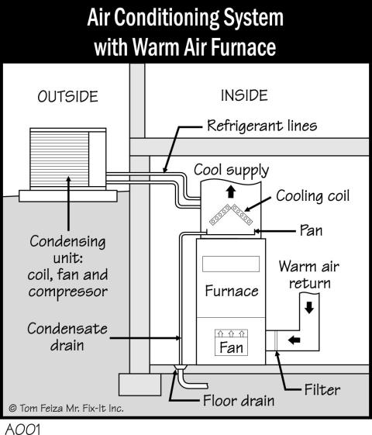

Inspection Limitations
Unit not tested. Outside temperature below 65° in the past 24 hours prohibited safe testing of unit. Testing an A/C unit in cold weather can cause damage to the unit.
Brand
Name tag not found.
Age
Approximately 26 years old.
Cooling Capacity and Efficiency
Not found/determined.
Outside Condensing Unit
Appears undamaged.

Air Conditioner Fuses
Max fuse: 30 amps, Fuse/breaker inside: 30 amps.
Indoor Cooling Unit
Unable to view indoor coil.
Temperature Drop
Unit not fired.
Distribution
Same as Furnace.
Filter
Same as Furnace.
Thermostat
Appears undamaged.

Space Heater

Testing of safety devices is beyond the scope of this inspection.

Gas Space Heater

Carbon Monoxide
Not tested.

Recommend professional service annually.

Heating

Inspection Limitations

Gas Space Heater
Pilot off. Unit not tested. Seller informed that unit works properly.

Location

Gas Space Heater
Garage.

Brand

Gas Space Heater
Carrier.

BTU/hr

Gas Space Heater
Not found.

Age

Gas Space Heater
>20 years.

System Condition

Gas Space Heater
Durable construction, Well maintained.

Fuel

Gas Space Heater
Natural gas.

Cabinet

Gas Space Heater
Inspected.

Piping/Valves

Gas Space Heater
Inspected.

Heat Exchanger

Gas Space Heater
Inspected.

Burners And Flame Observations

Gas Space Heater
Sealed/limited access to burners.

Exhaust Vent

Gas Space Heater
Metal vent pipe. Make sure pipe has 2" clearance from combustibles.

Thermostat

Gas Space Heater
Appears undamaged.

